Modify and analyse the sample project data and try to uncover market trends.

The University of Birmingham Bootcamp

Data Analysis Course

Submitted by

Rafiullah Mohammadzai

Dated: 10/08/2023

**Task 1:** Use conditional formatting to fill each cell in the column with a different color, depending on whether the associated campaign was successful, failed, cancel, or is currently live.

The collected data shows the performance of different artists, actors, and publishers.

The analysis shows that some countries are behind their goals, with Denmark being the country with the highest percentage of 17.82. However, there are some artists from Canada and Denmark who perform well.



The above Pivot Table illustrates the average donation from different industries.  Gaming/mobile games have a significant impact on the business, accounting for the highest average contribution of 1094.69

**Task 2:** Create a new sheet with a pivot table that analyses your initial worksheet to count how many campaigns were successful, failed, canceled, or are currently live per **category**.



The total number of successful campaigns is 280703; however, 30025 campaigns have been canceled, in addition to 181427 campaigns that have failed. Additionally, there are 7345 projects in the pipeline, or live which may change at any time.

**Task 3:**  in this task, Unix Timestamps were used for the deadline and launched at. This is used to convert timestamps to a normal date. However, more columns were generated such as date created conversion for launched at. And the date-ended conversion for the deadline.

* The table above shows the conversion of dates created and ended. This shows the date-created conversion, date-ended conversion, and deadline in Excel date format.

**Task 5: Statistical Analysis**

The following formulas are applied to extract the following below statistic.

* 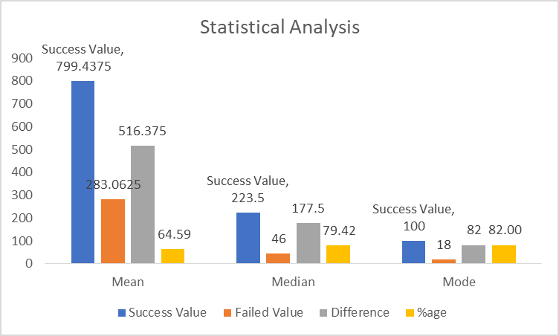The mean, median, max, min, variance and standard deviation of the number of backers.
* There is a greater mean or average success than failed, as shown by the figures: the average success is 799.4 against 283.1 for failed. Statistically, 516.4/- are more than failed, resulting in a 64.59% increase.
* The median value of success is 223.5, which is higher than the median value of failure, which is 46.0. Both the average and median provide a clear visual representation of the data.
* The data shows a high success value which is high variability this sample determines that this it was a successful campaign with the shown value. And it should be acceptable to the administration.